**Baza e te dhenave per nje bibliotek online.**

Se pari do te krijojme nje baze te dhenat per nje bibliotek online.

1. **Konceptimi i ER Diagram-it**

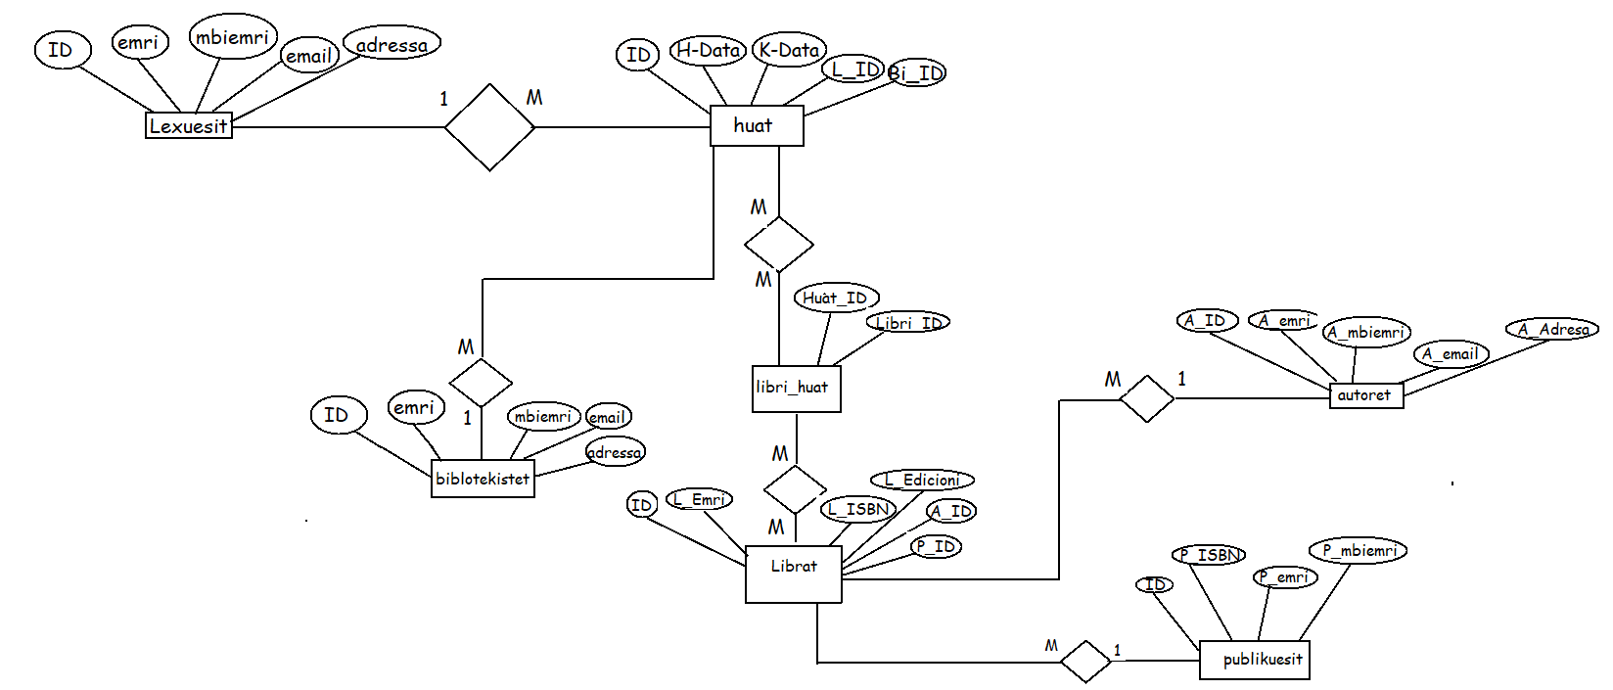

1. **Implementim i ER Diagram-it ne MySQL Workbanch**

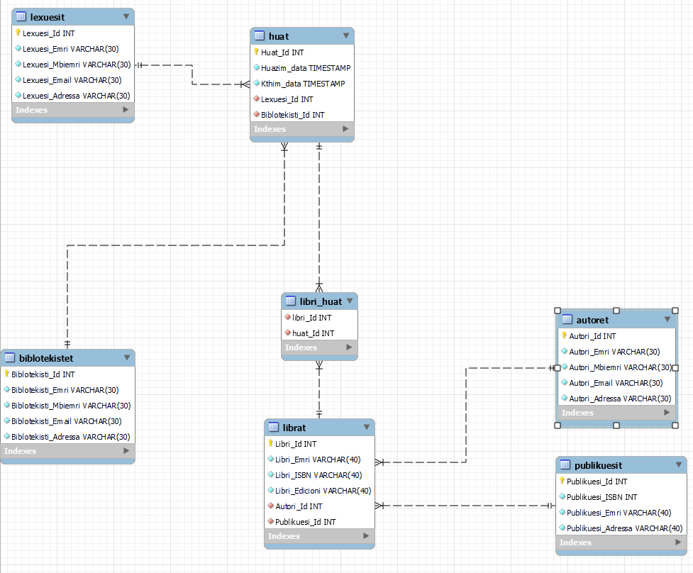

1. **Populimi i tabelave me te dhena**
2. *-- MySQL dump 10.13  Distrib 8.0.31, for Win64 (x86_64)*
3. *--*
4. *-- Host: localhost    Database: db_biblioteka*
5. *-- ------------------------------------------------------*
6. *-- Server version 8.0.31*
7. */*!40101 SET @OLD_CHARACTER_SET_CLIENT=@@CHARACTER_SET_CLIENT */*;
8. */*!40101 SET @OLD_CHARACTER_SET_RESULTS=@@CHARACTER_SET_RESULTS */*;
9. */*!40101 SET @OLD_COLLATION_CONNECTION=@@COLLATION_CONNECTION */*;
10. */*!50503 SET NAMES utf8 */*;
11. */*!40103 SET @OLD_TIME_ZONE=@@TIME_ZONE */*;
12. */*!40103 SET TIME_ZONE='+00:00' */*;
13. */*!40014 SET @OLD_UNIQUE_CHECKS=@@UNIQUE_CHECKS, UNIQUE_CHECKS=0 */*;
14. */*!40014 SET @OLD_FOREIGN_KEY_CHECKS=@@FOREIGN_KEY_CHECKS, FOREIGN_KEY_CHECKS=0 */*;
15. */*!40101 SET @OLD_SQL_MODE=@@SQL_MODE, SQL_MODE='NO_AUTO_VALUE_ON_ZERO' */*;
16. */*!40111 SET @OLD_SQL_NOTES=@@SQL_NOTES, SQL_NOTES=0 */*;
17. *--*
18. *-- Table structure for table `autoret`*
19. *--*
20. DROP TABLE IF EXISTS `autoret`;
21. */*!40101 SET @saved_cs_client     = @@character_set_client */*;
22. */*!50503 SET character_set_client = utf8mb4 */*;
23. CREATE TABLE `autoret` (
24. `Autori_Id` int NOT NULL AUTO_INCREMENT,
25. `Autori_Emri` varchar(30) NOT NULL,
26. `Autori_Mbiemri` varchar(30) NOT NULL,
27. `Autori_Email` varchar(30) NOT NULL,
28. `Autori_Adressa` varchar(30) NOT NULL,
29. PRIMARY KEY (`Autori_Id`)
30. ) ENGINE=InnoDB AUTO_INCREMENT=7 *DEFAULT* CHARSET=utf8mb4 *COLLATE*=utf8mb4_0900_ai_ci;
31. */*!40101 SET character_set_client = @saved_cs_client */*;
32. *--*
33. *-- Dumping data for table `autoret`*
34. *--*
35. LOCK TABLES `autoret` WRITE;
36. */*!40000 ALTER TABLE `autoret` DISABLE KEYS */*;
37. INSERT INTO `autoret` VALUES (1,'Naim','Frasheri','naim@gmail.com','Prishtine'),(2,'Gjergj','Fishta','gjergj@yahoo.com','Prizren'),(3,'Faik','Konica','faik.konica@gmail.com','Ferizaj'),(4,'Ismail ','Kadare','i.kadare@gmail.com','Gjakove'),(5,'Fan','Noli','f.noli@gmail.com','Mitrovic'),(6,'Sami','Frasheri','s.fr@gmail.com','Prishtine');
38. */*!40000 ALTER TABLE `autoret` ENABLE KEYS */*;
39. UNLOCK TABLES;
40. *--*
41. *-- Table structure for table `biblotekistet`*
42. *--*
43. DROP TABLE IF EXISTS `biblotekistet`;
44. */*!40101 SET @saved_cs_client     = @@character_set_client */*;
45. */*!50503 SET character_set_client = utf8mb4 */*;
46. CREATE TABLE `biblotekistet` (
47. `Biblotekisti_Id` int NOT NULL AUTO_INCREMENT,
48. `Biblotekisti_Emri` varchar(30) NOT NULL,
49. `Biblotekisti_Mbiemri` varchar(30) NOT NULL,
50. `Biblotekisti_Email` varchar(30) NOT NULL,
51. `Biblotekisti_Adressa` varchar(30) NOT NULL,
52. PRIMARY KEY (`Biblotekisti_Id`)
53. ) ENGINE=InnoDB AUTO_INCREMENT=4 *DEFAULT* CHARSET=utf8mb4 *COLLATE*=utf8mb4_0900_ai_ci;
54. */*!40101 SET character_set_client = @saved_cs_client */*;
55. *--*
56. *-- Dumping data for table `biblotekistet`*
57. *--*
58. LOCK TABLES `biblotekistet` WRITE;
59. */*!40000 ALTER TABLE `biblotekistet` DISABLE KEYS */*;
60. INSERT INTO `biblotekistet` VALUES (1,'Almedin','Agushi','a.agushi@gmail.com','Prishtine'),(2,'Hysen ','Gashi','h.gashi@gmail.com','Prizren'),(3,'Ylber','Veliu','y.veliji@yahoo.com','Kumanove');
61. */*!40000 ALTER TABLE `biblotekistet` ENABLE KEYS */*;
62. UNLOCK TABLES;
63. *--*
64. *-- Table structure for table `huat`*
65. *--*
66. DROP TABLE IF EXISTS `huat`;
67. */*!40101 SET @saved_cs_client     = @@character_set_client */*;
68. */*!50503 SET character_set_client = utf8mb4 */*;
69. CREATE TABLE `huat` (
70. `Huat_Id` int NOT NULL AUTO_INCREMENT,
71. `Huazim_data` timestamp NOT NULL *DEFAULT* CURRENT_TIMESTAMP,
72. `Kthim_data` timestamp NOT NULL *DEFAULT* CURRENT_TIMESTAMP,
73. `Lexuesi_Id` int NOT NULL,
74. `Biblotekisti_Id` int NOT NULL,
75. PRIMARY KEY (`Huat_Id`),
76. KEY `Lexuesi_Id` (`Lexuesi_Id`),
77. KEY `Biblotekisti_Id` (`Biblotekisti_Id`),
78. *CONSTRAINT* `huat_ibfk_1` *FOREIGN KEY* (`Lexuesi_Id`) *REFERENCES* `lexuesit` (`Lexuesi_Id`) *ON DELETE CASCADE* ON UPDATE CASCADE,
79. *CONSTRAINT* `huat_ibfk_2` *FOREIGN KEY* (`Biblotekisti_Id`) *REFERENCES* `biblotekistet` (`Biblotekisti_Id`) *ON DELETE CASCADE* ON UPDATE CASCADE
80. ) ENGINE=InnoDB AUTO_INCREMENT=9 *DEFAULT* CHARSET=utf8mb4 *COLLATE*=utf8mb4_0900_ai_ci;
81. */*!40101 SET character_set_client = @saved_cs_client */*;
82. *--*
83. *-- Dumping data for table `huat`*
84. *--*
85. LOCK TABLES `huat` WRITE;
86. */*!40000 ALTER TABLE `huat` DISABLE KEYS */*;
87. INSERT INTO `huat` VALUES (1,'2002-09-20 20:00:00','2020-10-20 20:00:00',1,1),(2,'2005-10-20 20:00:00','2020-11-20 21:00:00',2,2),(3,'2008-07-20 20:00:00','2015-10-20 20:00:00',3,3),(4,'2006-08-20 20:00:00','2010-09-20 20:00:00',4,2);
88. */*!40000 ALTER TABLE `huat` ENABLE KEYS */*;
89. UNLOCK TABLES;
90. *--*
91. *-- Table structure for table `lexuesit`*
92. *--*
93. DROP TABLE IF EXISTS `lexuesit`;
94. */*!40101 SET @saved_cs_client     = @@character_set_client */*;
95. */*!50503 SET character_set_client = utf8mb4 */*;
96. CREATE TABLE `lexuesit` (
97. `Lexuesi_Id` int NOT NULL AUTO_INCREMENT,
98. `Lexuesi_Emri` varchar(30) NOT NULL,
99. `Lexuesi_Mbiemri` varchar(30) NOT NULL,
100. `Lexuesi_Email` varchar(30) NOT NULL,
101. `Lexuesi_Adressa` varchar(30) NOT NULL,
102. PRIMARY KEY (`Lexuesi_Id`)
103. ) ENGINE=InnoDB AUTO_INCREMENT=5 *DEFAULT* CHARSET=utf8mb4 *COLLATE*=utf8mb4_0900_ai_ci;
104. */*!40101 SET character_set_client = @saved_cs_client */*;
105. *--*
106. *-- Dumping data for table `lexuesit`*
107. *--*
108. LOCK TABLES `lexuesit` WRITE;
109. */*!40000 ALTER TABLE `lexuesit` DISABLE KEYS */*;
110. INSERT INTO `lexuesit` VALUES (1,'Almedin','Agushi','a.agushi@gmail.com','Prishtine'),(2,'Hysen ','Gashi','h.gashi@gmail.com','Prizren'),(3,'Arbnor','Ramabaja','a.ramabaja@gmail.com','Ferizaj'),(4,'Kadri','Zeka','k.zeka@gmail.com','Gjakove');
111. */*!40000 ALTER TABLE `lexuesit` ENABLE KEYS */*;
112. UNLOCK TABLES;
113. *--*
114. *-- Table structure for table `librat`*
115. *--*
116. DROP TABLE IF EXISTS `librat`;
117. */*!40101 SET @saved_cs_client     = @@character_set_client */*;
118. */*!50503 SET character_set_client = utf8mb4 */*;
119. CREATE TABLE `librat` (
120. `Libri_Id` int NOT NULL AUTO_INCREMENT,
121. `Libri_Emri` varchar(40) NOT NULL,
122. `Libri_ISBN` varchar(40) NOT NULL,
123. `Libri_Edicioni` varchar(40) NOT NULL,
124. `Autori_Id` int NOT NULL,
125. `Publikuesi_Id` int NOT NULL,
126. PRIMARY KEY (`Libri_Id`),
127. KEY `Autori_Id` (`Autori_Id`),
128. KEY `Publikuesi_Id` (`Publikuesi_Id`),
129. *CONSTRAINT* `librat_ibfk_1` *FOREIGN KEY* (`Autori_Id`) *REFERENCES* `autoret` (`Autori_Id`),
130. *CONSTRAINT* `librat_ibfk_2` *FOREIGN KEY* (`Publikuesi_Id`) *REFERENCES* `publikuesit` (`Publikuesi_Id`)
131. ) ENGINE=InnoDB AUTO_INCREMENT=6 *DEFAULT* CHARSET=utf8mb4 *COLLATE*=utf8mb4_0900_ai_ci;
132. */*!40101 SET character_set_client = @saved_cs_client */*;
133. *--*
134. *-- Dumping data for table `librat`*
135. *--*
136. LOCK TABLES `librat` WRITE;
137. */*!40000 ALTER TABLE `librat` DISABLE KEYS */*;
138. INSERT INTO `librat` VALUES (1,'Bageti e Bujqesi','558548895','2',1,1),(2,'Historia e Skenderbeut','885887858','3',1,1),(3,'Lahuta e Malelis','552288999','1',2,2),(4,'Mrizi i Zanave','888545666','2',2,2),(5,'Doktor Gjilpera','558866884','3',3,3);
139. */*!40000 ALTER TABLE `librat` ENABLE KEYS */*;
140. UNLOCK TABLES;
141. *--*
142. *-- Table structure for table `libri_huat`*
143. *--*
144. DROP TABLE IF EXISTS `libri_huat`;
145. */*!40101 SET @saved_cs_client     = @@character_set_client */*;
146. */*!50503 SET character_set_client = utf8mb4 */*;
147. CREATE TABLE `libri_huat` (
148. `libri_Id` int NOT NULL,
149. `huat_Id` int NOT NULL,
150. KEY `libri_huat_libri_Id_Fk_idx` (`libri_Id`),
151. KEY `librat_huat_huat_Id_Fk_idx` (`huat_Id`),
152. *CONSTRAINT* `librat_huat_huat_Id_Fk` *FOREIGN KEY* (`huat_Id`) *REFERENCES* `huat` (`Huat_Id`) *ON DELETE CASCADE* ON UPDATE CASCADE,
153. *CONSTRAINT* `libri_huat_libri_Id_Fk` *FOREIGN KEY* (`libri_Id`) *REFERENCES* `librat` (`Libri_Id`) ON UPDATE CASCADE
154. ) ENGINE=InnoDB *DEFAULT* CHARSET=utf8mb4 *COLLATE*=utf8mb4_0900_ai_ci;
155. */*!40101 SET character_set_client = @saved_cs_client */*;
156. *--*
157. *-- Dumping data for table `libri_huat`*
158. *--*
159. LOCK TABLES `libri_huat` WRITE;
160. */*!40000 ALTER TABLE `libri_huat` DISABLE KEYS */*;
161. INSERT INTO `libri_huat` VALUES (3,1),(2,2);
162. */*!40000 ALTER TABLE `libri_huat` ENABLE KEYS */*;
163. UNLOCK TABLES;
164. *--*
165. *-- Table structure for table `publikuesit`*
166. *--*
167. DROP TABLE IF EXISTS `publikuesit`;
168. */*!40101 SET @saved_cs_client     = @@character_set_client */*;
169. */*!50503 SET character_set_client = utf8mb4 */*;
170. CREATE TABLE `publikuesit` (
171. `Publikuesi_Id` int NOT NULL AUTO_INCREMENT,
172. `Publikuesi_ISBN` int NOT NULL,
173. `Publikuesi_Emri` varchar(40) NOT NULL,
174. `Publikuesi_Adressa` varchar(40) NOT NULL,
175. PRIMARY KEY (`Publikuesi_Id`)
176. ) ENGINE=InnoDB AUTO_INCREMENT=6 *DEFAULT* CHARSET=utf8mb4 *COLLATE*=utf8mb4_0900_ai_ci;
177. */*!40101 SET character_set_client = @saved_cs_client */*;
178. *--*
179. *-- Dumping data for table `publikuesit`*
180. *--*
181. LOCK TABLES `publikuesit` WRITE;
182. */*!40000 ALTER TABLE `publikuesit` DISABLE KEYS */*;
183. INSERT INTO `publikuesit` VALUES (1,558548895,'Ramadan','Tiran'),(2,558558885,'Azem','Sarand'),(3,855588548,'Besnik','Prishtine'),(4,888858894,'Shkodran','Ferizaj'),(5,554466685,'Fisnik','Prizren');
184. */*!40000 ALTER TABLE `publikuesit` ENABLE KEYS */*;
185. UNLOCK TABLES;
186. */*!40103 SET TIME_ZONE=@OLD_TIME_ZONE */*;
187. */*!40101 SET SQL_MODE=@OLD_SQL_MODE */*;
188. */*!40014 SET FOREIGN_KEY_CHECKS=@OLD_FOREIGN_KEY_CHECKS */*;
189. */*!40014 SET UNIQUE_CHECKS=@OLD_UNIQUE_CHECKS */*;
190. */*!40101 SET CHARACTER_SET_CLIENT=@OLD_CHARACTER_SET_CLIENT */*;
191. */*!40101 SET CHARACTER_SET_RESULTS=@OLD_CHARACTER_SET_RESULTS */*;
192. */*!40101 SET COLLATION_CONNECTION=@OLD_COLLATION_CONNECTION */*;
193. */*!40111 SET SQL_NOTES=@OLD_SQL_NOTES */*;
194. *-- Dump completed on 2022-11-16 13:31:38*
195. **MySQL pyetesoret (queries)**